**Dr. BABASAHEB AMBEDKAR TECHNOLOGICAL UNIVERSITY, LONERE**

SHRI TULJABHAVANI COLLEGE OF ENGINEERING, TULJAPUR.

DEPARTMENT OF COMPUTER SCIENCE & ENGINEERING

(2023-24)



**Study Circle**

*Submitted by*

**Name: Digambar Chandrakant Kumbhar, Roll No.:4505, PRN No. T2021311242006**

*Under the guidance of*

**Prof. Sachin S. Kale**

**DR. BABASAHEB AMBEDKAR TECNOLOGICAL UNIVERSITY, LONERE**

**CERTIFICATE**



This is to certify that the Project report entitled “**Study Circle”,** submitted by Mr**. Digambar Chandrakant Kumbhar, Mr. Onkar Netaji Jadhav, Mr. Samarth Satish Khurud and Mr. Pranav Prashant Jawalkar** is the bonafide work completed under my guidance in the partial fulfillment for the award of B.Tech in Computer Science and Engineering ofDr. Babasaheb Ambedkar Technological University, Lonere .

Place: Tuljapur

Date:

**Prof. Sachin S. Kale**   **Prof. D. J. Waghmare**

Guide HOD

Department of CSE

Principal

STB College of Engineering, Tuljapur

**DECLARATION**

I / We hereby declare that the Project Report entitled “Study Circle” is an authentic record of my own work for the award of degree of B.Tech. (CSE), Shri Tuljabhavani College of Engineering, Tuljapur under the guidance of Prof. Sachin S. Kale

Date: ___________

**Name: Kumbhar Digambar Chandrakant, Roll No.: 4505, PRN No. T2021311242006**

**ACKNOWLEDGEMENT**

With immense pleasure I/ We, by **Mr. Kumbhar Digambar Chandrakant, Mr. Jadhav Onkar Netaji, Mr. Khurud Samarth Satish** and **Mr. Jawalkar Pranav Prashant** presenting “**Study Circle**” Project report as a part of the curriculum of B.Tech in Computer Science & Engineering . I wish to thank all the people who gave me unending support.

I take this opportunity to express my deep sense of gratitude to my guide Prof. Sachin S. Kale, for their valuable guidance and inspiration and also to our Principal Prof. P. H. Hangargekar Sir for their encouragement and notable guidance. My/Our special thanks to Prof. D. J. Waghmare , HOD of CSE department and staff who gives precious guidance.

Date: ___________

**Contents**

**Chapter Page no.**

1. Introduction 1
2. Need 3
3. Who can access 5
4. Student section 7
5. Department section 9
6. College section 11
7. Evaluation 13
8. Practice 15
9. Contest 17
10. Conferences 19
11. Library 21
12. Notice board 23
13. Privacy 25
14. Technology Stack 27
15. ER diagram 29
16. Flow chart 31
17. File and Folder Structure 34
18. Conclusion 38
19. Research 39
20. Project Access Code Details 40
21. Referencess 41

Chapter 1

Introduction

In today's fast-paced world, education has become more important than ever. With the rise of technology and the internet, the way we learn and access information has changed drastically. The traditional ways of teaching and learning are no longer sufficient to keep up with the demands of the modern world. This is where Study Circle comes in - a web page that provides all the necessary resources and tools for students to excel in their studies.

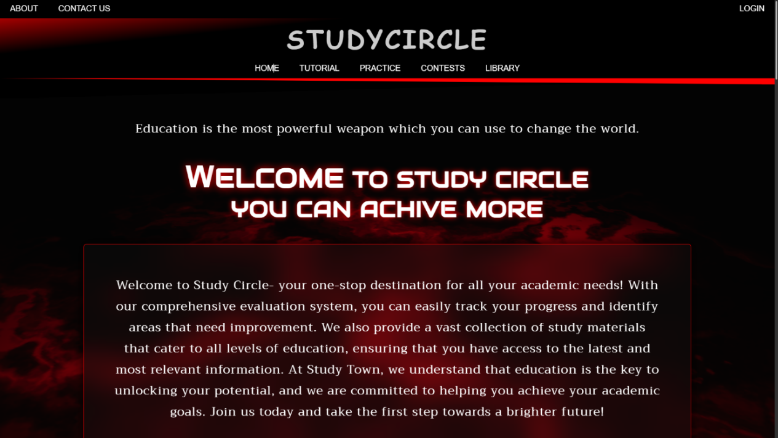

Study Circle is a comprehensive educational platform that aims to provide students with everything they need to succeed in their academic pursuits. It is an online platform that offers students the opportunity to access study materials, interact with teachers and peers, and monitor their academic progress. Study Circle is designed to make learning more accessible, convenient, and engaging for students of all ages and levels.

The idea behind Study Circle is to provide a one-stop-shop for all students' educational needs. The platform offers a wide range of study materials, including textbooks, practice tests, and video lectures, all of which are designed to help students learn more effectively. Additionally, Study Circle provides a platform for teachers to interact with students, assign and grade assignments, and provide feedback. This helps students to understand their strengths and weaknesses and work towards improving their academic performance.

One of the key features of Study Circle is its focus on personalization. The platform uses advanced algorithms to tailor the learning experience to each student's unique needs and learning style. This ensures that every student gets the most out of their time on the platform, regardless of their level of academic ability.

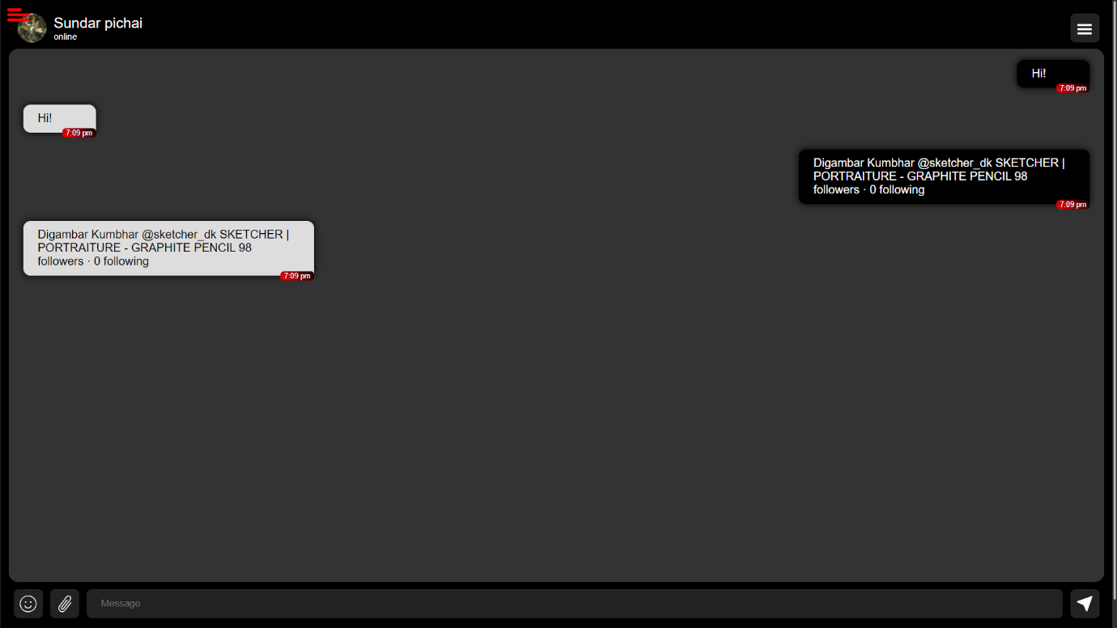

Study Circle also places a strong emphasis on community building. The platform provides students with the opportunity to connect with their peers, collaborate on projects, and learn from each other. This helps to create a supportive learning environment that encourages students to ask questions and share ideas.

Another significant benefit of Study Circle is its flexibility. The platform is accessible from anywhere with an internet connection, meaning that students can study at their own pace and on their own schedule. This makes it ideal for students who have busy schedules or who live in remote areas.

In conclusion, Study Circle is an innovative platform that is transforming the way students learn and access educational resources. It offers a comprehensive range of study materials, interactive tools, and personalized learning experiences, all of which are designed to help students achieve their academic goals. Study Circle is the future of education, and we are excited to be at the forefront of this transformation.

CHPTER 2

Need

In today's fast-paced and competitive world, education has become an essential part of everyone's life. Whether it is for personal growth or professional advancement, learning and gaining knowledge is crucial. With the advent of technology, online education has gained immense popularity in recent times, and the pandemic has further accelerated its growth. However, online learning comes with its own set of challenges. It requires discipline, motivation, and dedication to be successful, and students often struggle to keep up with the pace of the online curriculum. This is where Study Circle comes in - an online platform that provides all the necessary resources and tools for students to succeed in their academic pursuits.

The need for Study Circle stems from the challenges faced by students in the traditional education system. The traditional education system often falls short in catering to the individual learning needs of each student, resulting in a lack of engagement and interest in learning. This, in turn, leads to poor academic performance and lower confidence levels among students. Additionally, students often face difficulties in finding the right study material and resources to support their learning. With Study Circle, all of these challenges are addressed, making online learning more accessible, engaging, and effective for students.

One of the significant benefits of Study Circle is the ease of access to study material. The platform provides a vast library of study material, including textbooks, journals, research papers, and other educational resources. This eliminates the need for students to spend hours scouring the internet for the right material, saving them valuable time and effort. Moreover, the study material on Study Circle is curated and reviewed by subject matter experts, ensuring the highest quality of education for students.

Another important feature of Study Circle is its assessment and evaluation tools. The platform provides students with regular assessments and evaluations, allowing them to track their progress and identify areas of improvement. The assessments are designed to cater to different learning styles and abilities, ensuring that each student receives personalized feedback and guidance. This not only helps students improve their academic performance but also boosts their confidence and motivation levels.

In addition to the study material and assessment tools, Study Circle also provides a practice platform for students to apply their learning. The platform offers various practice tests, quizzes, and simulations that allow students to put their knowledge into practice. This helps students develop a better understanding of the concepts and improves their retention of the material.

Furthermore, Study Circle also offers a community platform for students to interact with each other and their teachers. This fosters a sense of belonging and collaboration among students, promoting a positive learning environment. Students can share their knowledge, discuss ideas, and seek help from their peers and teachers, enhancing their learning experience.

In conclusion, the need for Study Circle is evident in today's education system. Online learning has become the new norm, and Study Circle provides a comprehensive platform for students to learn, practice, and excel in their academic pursuits. With its vast library of study material, assessment and evaluation tools, practice platform, and community platform, Study Circle caters to the individual learning needs of each student, ensuring their success.

Chapter 3

Who can access

Study Circle is a web-based platform designed to provide students with a comprehensive set of tools to help them with their academic journey. The platform offers a wide range of features, including student evaluation, study materials, a practice platform, and more. One of the key aspects of Study Circle is that it is accessible to three main categories of users: colleges, departments, and students.



Firstly, colleges can access Study Circle to manage their academic operations efficiently. The platform provides a range of features that allow college administrators to monitor and track the progress of their students. For instance, colleges can use the student evaluation tool to get insights into their students' performance in real-time. They can also use the study material feature to provide students with relevant and high-quality study materials that align with their curriculum. Furthermore, the practice platform on Study Circle allows colleges to create practice questions, quizzes, and mock tests to help students prepare for their exams. Colleges can also use Study Circle to manage their departments and faculty, assign tasks, and keep track of their operations.

Secondly, departments within colleges can also access Study Circle to manage their academic operations. Departments can use the platform to manage their courses, monitor student progress, and provide students with the relevant study materials. They can also use the student evaluation tool to get insights into their students' performance, identify areas where students need more help, and make informed decisions to improve their academic outcomes. Departments can also use the practice platform to create practice quizzes, tests, and assignments that help students to reinforce their learning and prepare for their exams.

Lastly, students can access Study Circle to improve their academic outcomes. The platform provides a range of study materials that are relevant to their courses and curriculum. Students can also use the platform to monitor their academic progress, access their performance reports, and identify areas where they need more help. They can also use the practice platform to reinforce their learning and prepare for their exams. The platform allows students to collaborate with their peers, interact with their instructors, and access a range of resources that help them succeed in their academic journey.

In conclusion, Study Circle is a comprehensive platform that provides a range of tools to help colleges, departments, and students manage their academic operations efficiently. It offers a range of features that enable colleges and departments to monitor student progress, manage their faculty and courses, and improve their academic outcomes. Students can also benefit from Study Circle by accessing high-quality study materials, monitoring their academic progress, and preparing for their exams. Study Circle is a versatile and user-friendly platform that caters to the needs of a wide range of users, making it an essential tool for managing academic operations in colleges and departments.

Chapter 4

Student section

The student section in Study Circle is an essential component of the web page, as it provides students with all the necessary resources to excel in their studies. This section is designed to cater to the academic needs of students from different educational backgrounds, such as high school, college, and university. The following is an in-depth explanation of the student section in Study Circle.

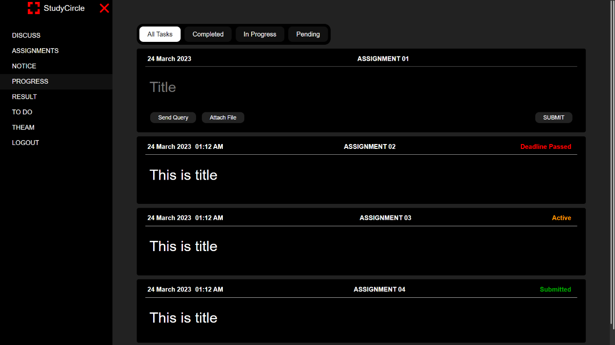

Study Material:

The study material is the core of the student section. It contains all the necessary resources such as notes, books, videos, and lectures on various subjects. The study material is categorized into different subjects, making it easier for students to find what they are looking for. Students can access the study material for free, which means they can learn at their own pace and convenience.

Online Tests and Quizzes:

The online test and quizzes section is another essential component of the student section. It contains a wide range of tests and quizzes, designed to help students test their knowledge and improve their understanding of various subjects. The tests are timed, which adds an element of urgency and prepares students for real-life exams. Additionally, students can get instant feedback on their performance, allowing them to identify their strengths and weaknesses.

Discussion Forums:

The discussion forums are an excellent platform for students to share their ideas and collaborate with their peers. Students can create and participate in discussion forums on various subjects, allowing them to gain a better understanding of the topic. The discussion forums also provide an opportunity for students to ask questions and seek guidance from their teachers and peers.

Assignment Section:

The assignment section provides students with a platform to submit their assignments online. It eliminates the need for physical submission, which is a convenient option for students. Additionally, the assignment section allows teachers to grade and provide feedback on assignments, helping students improve their understanding of the subject.

Grades and Progress:

The grades and progress section provides students with a comprehensive overview of their academic progress. It includes their grades, attendance, and other academic details, allowing them to keep track of their academic performance. The grades and progress section also enables students to identify their strengths and weaknesses, helping them make informed decisions about their studies.

In conclusion, the student section in Study Circle is a comprehensive and user-friendly platform designed to cater to the academic needs of students. It provides students with a wide range of resources and tools to excel in their studies. The study material, online tests and quizzes, discussion forums, assignment section, and grades and progress section are all designed to make learning easier and more convenient for students. Therefore, the student section in Study Circle is an excellent resource for students who want to excel in their studies.

Chapter 5

Department section

The Department section in Study Circle is designed to cater to the academic needs of the departments in educational institutions. It is a comprehensive platform that facilitates smooth communication between the faculty members, administrative staff, and students.

The department section provides various features that help the department to manage its academic activities effectively. The platform offers a centralized system for the department to publish information related to academic programs, examinations, schedules, and events.

One of the key features of the Department section is the ability to manage courses and syllabi. The faculty members can upload the course content, syllabi, and other relevant materials on the platform for the students to access. This feature helps in organizing the course content and ensures that the students have access to all the necessary information related to the courses they are enrolled in.

Another important feature of the Department section is the assessment and evaluation system. The platform allows the faculty members to create and manage assessments, including assignments, quizzes, and exams. The system automatically grades the assessments and provides instant feedback to the students. This helps in improving the quality of the assessments and ensures that the students receive timely feedback on their performance.

The Department section also provides a platform for communication between the faculty members and students. The platform allows the faculty members to communicate with the students regarding academic matters, such as assignments, exams, and class schedules. The students can also use the platform to communicate with their peers and faculty members.

The Department section also has a feature for managing attendance. The faculty members can take attendance for the classes they teach and record it on the platform. This helps in tracking the attendance of the students and ensures that they attend the classes regularly.

The Department section also provides a platform for conducting online discussions and forums. The faculty members can create discussion forums for the students to participate in and share their views on various topics related to their courses. This helps in promoting collaboration and interaction among the students.

Overall, the Department section in Study Circle is a comprehensive platform that helps the department to manage its academic activities effectively. It provides various features that facilitate smooth communication between the faculty members, administrative staff, and students. The platform also helps in organizing course content, assessments, and evaluations, and promoting collaboration and interaction among the students.

Chapter 6

College section

The college section in Study Circle is designed to cater to the needs of the college administration. It serves as a platform for the college management to monitor the academic progress of students, manage faculty members, and handle other administrative tasks.



One of the key features of the college section is the dashboard that provides a comprehensive overview of the college's academic performance. The dashboard includes various charts and graphs that represent data related to the overall performance of the college. The college authorities can access this data to make informed decisions and take necessary steps to improve the academic performance of the college.

Another important feature of the college section is the faculty management system. It allows the college administration to manage faculty members efficiently. The system allows the college authorities to track the attendance of faculty members, evaluate their performance, and manage their leave and work schedules. The faculty members can also access their personal dashboard to manage their tasks and track their performance.

The college section also includes a student management system that enables the college authorities to manage the academic progress of students. The system provides a comprehensive view of the academic progress of each student, including their attendance, marks, and performance in various tests and assignments. The college administration can use this data to identify students who need help and provide them with the necessary support to improve their academic performance.

Moreover, the college section of Study Circle also facilitates communication between the college administration, faculty members, and students. The system provides a centralized platform where students can access important information related to their academic performance, such as schedules, syllabus, and course materials. Students can also interact with their teachers and college administration through the system to clarify doubts, submit assignments, and get feedback on their performance.

Overall, the college section in Study Circle provides a comprehensive platform for the college administration to manage the academic progress of students, manage faculty members, and handle other administrative tasks efficiently. It promotes transparency, enhances communication, and helps the college administration to make informed decisions to improve the overall academic performance of the college.

Chapter 7

Evolution

The evaluation system in Study Circle is a comprehensive system designed to track and measure students' progress in their academic pursuits. It is a critical tool that helps both students and educators evaluate how effectively students are learning and progressing in their studies.

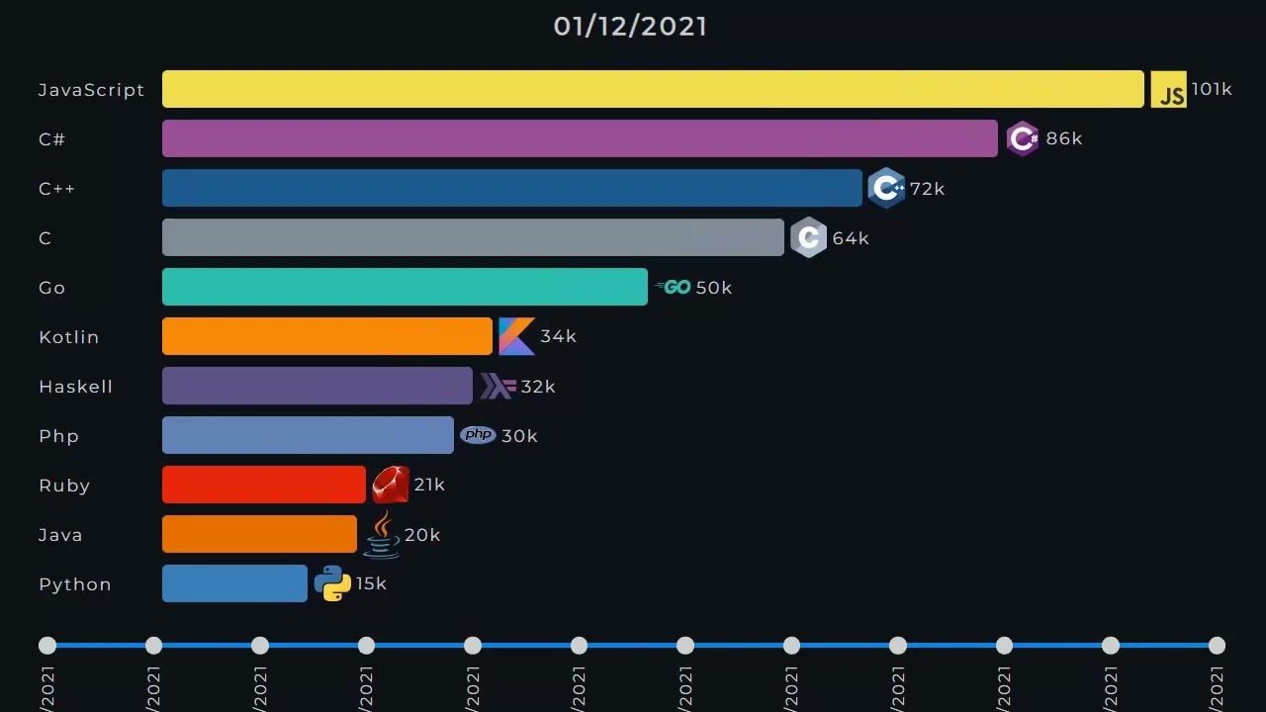

The evaluation system in Study Circle is designed to be easy to use, flexible and customizable to the unique needs of each student. It provides various evaluation metrics, such as quizzes, exams, assignments, and projects, to measure students' knowledge and understanding of various concepts and topics.

The evaluation system in Study Circle provides a holistic approach to student assessment, considering not only academic achievement but also other essential skills such as critical thinking, problem-solving, collaboration, and communication.

The evaluation system in Study Circle offers real-time feedback to students, enabling them to track their progress, identify areas of weakness, and take corrective action to improve their performance. It helps students to understand their strengths and weaknesses, providing them with an opportunity to work on their areas of weakness and enhance their strengths.

The evaluation system in Study Circle enables educators to assess their students' performance comprehensively. It provides educators with an overview of their students' progress, enabling them to identify areas of weakness and design effective teaching strategies to improve their students' academic performance.

The evaluation system in Study Circle offers a secure and user-friendly platform for educators to input, manage, and evaluate student performance data. It enables educators to provide students with valuable feedback, promoting their learning and academic growth.

In conclusion, the evaluation system in Study Circle is a vital component of the online learning platform. It provides students with the tools they need to measure their progress and evaluate their performance, while also enabling educators to design effective teaching strategies that promote their students' academic growth. It is an excellent tool that enhances the learning experience, helping students to develop a better understanding of the subjects and topics they are studying.

Chapter 8

Practice

The practice section of Study Circle is a valuable resource for students looking to enhance their understanding and knowledge of various subjects. It is a comprehensive platform that provides students with access to a wide range of practice materials, including quizzes, tests, and other interactive resources. The practice section is designed to help students assess their understanding of the material, identify areas where they need to focus their efforts, and provide feedback to help them improve their performance.

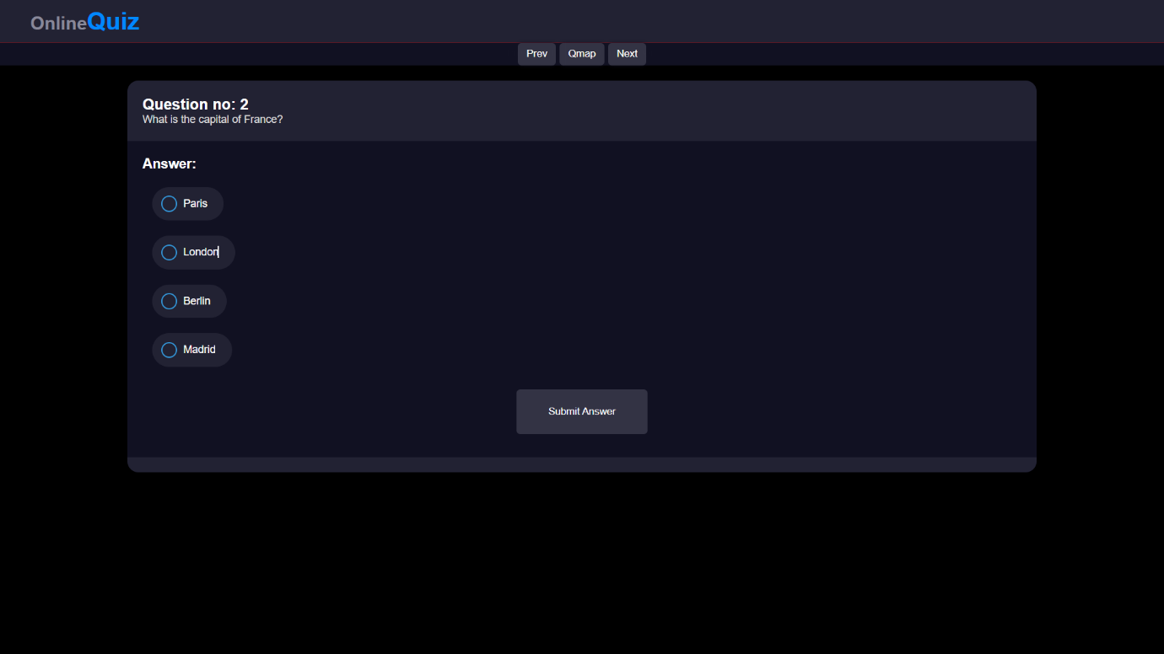

The practice section is divided into different categories based on subject matter, making it easy for students to find the resources they need to study. Each category contains a variety of resources, including practice quizzes, tests, and interactive games. The practice quizzes are designed to be challenging, but not overwhelming, allowing students to test their knowledge of the material in a low-pressure environment.

One of the key features of the practice section is its flexibility. Students can choose to complete the practice quizzes at their own pace, allowing them to work on their own schedule and focus on areas where they need more practice. The quizzes are also interactive, providing students with immediate feedback on their answers and allowing them to track their progress over time.

In addition to quizzes and tests, the practice section also offers other resources designed to help students improve their performance, such as study guides and tutorial videos. These resources provide students with additional information and support to help them better understand the material and achieve their academic goals.

The practice section of Study Circle is also designed to be user-friendly and accessible. It is easy to navigate, and the resources are organized in a logical and intuitive way. Students can access the practice section from any device with an internet connection, making it a convenient and flexible option for studying on-the-go.

Overall, the practice section of Study Circle is an essential resource for students looking to improve their understanding of various subjects. It provides a wide range of interactive resources, designed to help students assess their understanding of the material, identify areas where they need to focus their efforts, and provide feedback to help them improve their performance. With its flexibility, user-friendly design, and comprehensive resources, the practice section is an excellent tool for students looking to excel academically.

Chapter 9

Contest

The contest section of Study Circle is a platform that provides an opportunity for students to showcase their academic abilities and compete with their peers on various topics. It is a platform that encourages students to enhance their knowledge, learning, and problem-solving skills. The contests are designed to challenge students to think critically and creatively.

The contest section includes different types of contests such as quizzes, debates, group discussions, and competitions. Students can participate in these contests based on their interests and academic strengths. The contests are open to all students who are registered on the Study Circle platform.

The quiz contests are designed to test the students' knowledge on different topics such as general knowledge, current affairs, science, history, and literature. The quizzes are timed, and the students who score the highest are declared the winners. These quizzes are an excellent way for students to test their knowledge and learn new things.

The debate and group discussion contests are designed to enhance the students' communication and critical thinking skills. These contests require students to form groups and discuss a topic of interest. They must research and present their ideas in a structured and logical manner. The debates and group discussions are judged by experts in the field, and the students with the most compelling arguments are declared the winners.

The competition section includes various academic contests such as math Olympiad, science fairs, and language competitions. These contests are designed to encourage students to excel in their academic pursuits and showcase their talents. The competitions are judged by experts in the field, and the students who perform the best are declared the winners.

The contest section of Study Circle is an excellent platform for students to showcase their academic abilities and learn from their peers. It provides a competitive environment that encourages students to push themselves to achieve their best. The contests also provide an opportunity for students to interact with experts in various fields and gain valuable insights into different subjects.

In conclusion, the contest section of Study Circle is a valuable platform that provides students with the opportunity to enhance their academic abilities and compete with their peers. It is an excellent tool for students to learn and grow while having fun. It encourages critical thinking, creativity, and communication skills, all of which are essential for success in any field.

Chapter 10

Conferences

Conferences are an integral part of any academic community, and Study Circle recognizes the importance of providing a platform for students, teachers, and researchers to come together and exchange ideas, knowledge, and expertise. Study Circle's conference section is designed to enable participants to hold virtual meetings, discuss research findings, and collaborate on new projects.

The conference section provides a platform for users to organize and participate in online meetings and webinars. It allows users to create conference rooms, set up schedules, and invite participants to join the sessions. The platform is equipped with video conferencing features that enable users to interact in real-time, share screens, and engage in group discussions.

Through the conference section, students can meet with their peers and teachers to discuss course material, ask questions, and receive feedback. They can collaborate with their peers on projects and assignments, and receive guidance and support from their teachers. The conference section provides an opportunity for students to engage with their course material in a more interactive and collaborative manner, which can enhance their learning experience.

Furthermore, the conference section provides an opportunity for researchers to present their findings, engage in scholarly discussions, and collaborate on new research projects. It allows researchers to connect with other experts in their field and share their expertise. The platform enables them to organize and participate in virtual workshops, symposiums, and other academic events, which can contribute to the growth of their research community.

In addition to academic events, Study Circle's conference section can also facilitate meetings for student organizations and clubs. It can be used as a platform for these groups to organize events, discuss initiatives, and engage with their members.

One of the most significant advantages of Study Circle's conference section is its accessibility. Users can access the platform from anywhere in the world, as long as they have an internet connection. This feature eliminates geographical barriers and enables participants to connect with others regardless of their location.

The conference section is also equipped with advanced security features that ensure the privacy and safety of participants. It employs end-to-end encryption to secure all data transmission and ensures that only authorized users can access the platform.

In conclusion, Study Circle's conference section provides an excellent opportunity for students, teachers, and researchers to come together, share ideas, and collaborate on new projects. It enables users to organize and participate in virtual meetings, engage in group discussions, and connect with others in their field. The platform is accessible and secure, ensuring the privacy and safety of all participants.

Chapter 11

Library

The library section of Study Circle is a comprehensive resource hub that provides students with access to a wide range of study materials. This section is designed to help students broaden their knowledge, understand key concepts, and reinforce their understanding of various subjects. The library section offers an extensive collection of textbooks, study guides, reference materials, and other resources that are categorized by subject and topic for easy access.

One of the unique features of the library section is that students can contribute their own study materials, such as notes, practice tests, and study guides. These contributions are reviewed by qualified teachers to ensure their quality and accuracy. This feature allows students to actively engage with the learning community and share their knowledge and insights with their peers.

The library section is organized by subject, and students can easily find resources related to their specific course of study. For example, if a student is studying mathematics, they can easily navigate to the mathematics section of the library and find a range of resources on topics such as algebra, geometry, calculus, and statistics. Similarly, if a student is studying literature, they can access resources related to poetry, fiction, drama, and other literary genres.

In addition to textbooks and study materials, the library section also offers multimedia resources such as videos, podcasts, and other audio-visual materials. This makes learning more engaging and interactive, and allows students to explore complex topics in new and exciting ways.

One of the key advantages of the library section is that it is constantly updated with new and relevant resources. This ensures that students have access to the most up-to-date information and materials, and that their learning experience is enhanced with the latest research and thinking in their field of study.

Overall, the library section of Study Circle is a valuable resource for students at all levels of study. It offers a comprehensive collection of study materials, multimedia resources, and contributions from students and teachers alike, and is designed to support and enhance the learning experience of students in a wide range of subjects.

Chapter 12

Notice board

The notice board section in Study Circle is an essential feature that enables the dissemination of information to students, faculty, and staff in real-time. The notice board is accessible for college and department login, and it is a centralized platform where important announcements, notifications, and updates are posted. It provides students with the necessary information and guidance required to succeed in their academic pursuits.

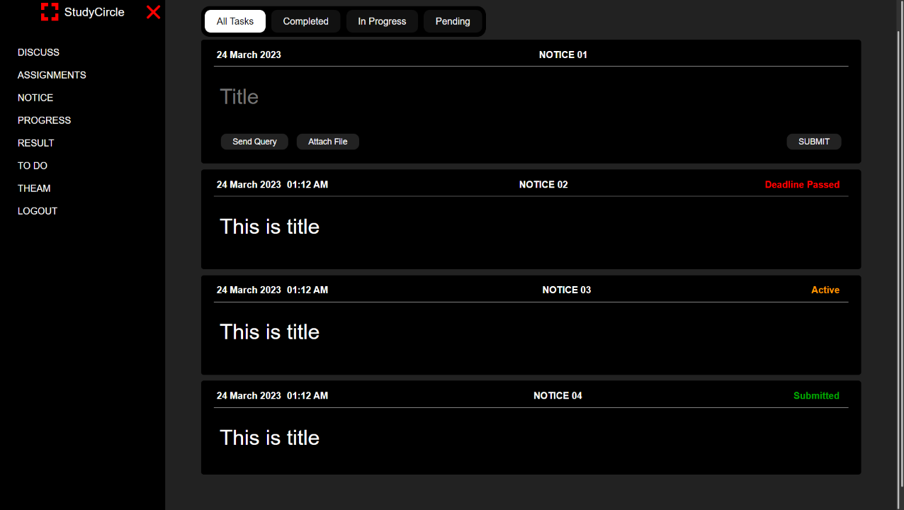

The notice board serves as a virtual bulletin board where information regarding various academic, social, and cultural events can be shared with students. The notice board keeps students informed about upcoming college festivals, events, and other important updates related to their coursework. It also provides updates about exam dates, deadlines for submitting assignments, and other crucial academic deadlines. This section is vital as it helps students stay organized and plan their schedules accordingly.

Furthermore, the notice board is also an excellent platform for the college and department administrators to communicate with students. Important announcements such as changes in course schedules, faculty changes, or any other updates relevant to students' academic pursuits can be shared through this platform.

In addition to academic updates, the notice board section also serves as a platform for sharing social and cultural event updates. It provides students with an opportunity to participate in extracurricular activities, community services, and other social events happening on campus. This promotes student engagement and helps foster a sense of community on campus.

Another important feature of the notice board section is that it allows students to post notices about events or activities that they are organizing. Students can use this platform to advertise events, seek participants or volunteers, or provide information about any upcoming cultural or social events. This not only provides students with an opportunity to showcase their leadership and organizational skills but also enables them to develop a sense of ownership and responsibility towards the college community.

Moreover, the notice board section is designed to be user-friendly and easily accessible. It is designed to ensure that students can view and access important updates and information without any difficulties. The platform is optimized for mobile devices and can be accessed through the Study Circle mobile app, enabling students to stay up-to-date on the go.

In conclusion, the notice board section in Study Circle is an essential feature that facilitates communication between students, faculty, and staff. It is a centralized platform where important announcements and updates can be shared, providing students with the necessary information and guidance required to succeed in their academic pursuits. The notice board section is designed to promote student engagement, foster a sense of community on campus, and ensure that students can access relevant information quickly and easily.

Chapter 13

Privacy

Privacy is an essential aspect of any online platform, and Study Circle is no exception. As an educational platform, Study Circle takes the privacy and security of its users' information seriously. The platform is designed to ensure that users' personal information, academic records, and other sensitive data are protected from unauthorized access, disclosure, or misuse.

To ensure the privacy of users, Study Circle has implemented various measures, including the use of encryption technologies to secure communication between the platform and its users. All data transmitted between users and the platform is encrypted to prevent interception by third parties. The platform also uses advanced security protocols to protect against hacking and cyber-attacks.

One of the critical aspects of privacy in Study Circle is the protection of personal information. Users' personal information, including name, email address, and phone number, is collected only for the purpose of registration and communication between the platform and the user. This information is stored securely and is only accessible to authorized personnel.

Similarly, academic records and other sensitive data of students are also kept private and confidential. Only the authorized users, including teachers and administrative staff, have access to these records. The platform ensures that any data shared by the students is kept confidential and used only for academic purposes.

Another aspect of privacy in Study Circle is the protection of intellectual property. The platform allows students to upload study materials, but it also has measures to ensure that these materials do not violate any copyright or intellectual property laws. The platform requires that all uploaded materials are original or have proper attribution to the original source.

Study Circle also has a robust privacy policy that outlines its commitment to privacy and data protection. The policy explains the type of information the platform collects, how it uses the information, and how it safeguards the information from unauthorized access. The policy also outlines users' rights, including the right to access, correct, or delete their personal information.

In conclusion, privacy is a crucial aspect of Study Circle, and the platform takes it seriously. By implementing various measures, Study Circle ensures that users' personal information and academic records are kept confidential and secure. This helps to create a safe and conducive environment for learning, where students can freely share their thoughts and ideas without fear of privacy violations.

Chapter 14

Technology Stack

The "Study Circle" application is built using a comprehensive and modern technology stack that ensures a robust, scalable, and user-friendly platform. This section provides an overview of the various technologies used in both the frontend and backend development of the application.

**Frontend**

The frontend of the "Study Circle" application is developed using React, a popular JavaScript library for building user interfaces. React's component-based architecture allows for efficient and reusable UI components. The frontend also leverages several other libraries and tools to enhance the user experience and streamline development.

#### Backend

The backend of the "Study Circle" application is powered by Node.js and Express.js. Node.js provides a JavaScript runtime that is well-suited for building scalable network applications, while Express.js offers a robust set of features for web and mobile applications. The backend stack also includes.

|  |  |  |  |
| --- | --- | --- | --- |
| **Layer** | **Technology** | **Version** | **Description** |
| Frontend | React | 18.2.0 | A JavaScript library for building user interfaces. |
|  | React DOM | 18.2.0 | A package that provides DOM-specific methods that can be used at the top level of a web app. |
|  | React Scripts | 5.0.1 | Scripts and configuration used by Create React App. |
|  | SASS | 1.72.0 | CSS preprocessor that adds power and elegance to the basic language. |
|  | Axios | 1.6.8 | Promise-based HTTP client for the browser and Node.js. |
|  | Dompurify | 3.1.3 | A DOM-only version of Google Caja's HTML sanitizer. |
|  | Marked | 12.0.2 | A markdown parser and compiler. |
|  | js-cookie | 3.0.5 | A simple, lightweight JavaScript API for handling cookies. |
|  | React Google Charts | 4.0.1 | React component for Google Charts. |
|  | Web Vitals | 2.1.4 | A library for measuring performance vitals. |
|  | dotenv | 16.4.5 | Loads environment variables from a .env file into process.env. |
|  | React Router DOM | 6.23.0 | Declarative routing for React web applications. |
|  | Socket.IO Client | 4.0.0 | Enables real-time, bidirectional and event-based communication between the browser and the server. |
| Backend | Node.js | Latest | A JavaScript runtime built on Chrome's V8 JavaScript engine. |
|  | Express | 4.19.2 | Fast, opinionated, minimalist web framework for Node.js. |
|  | CORS | 2.8.5 | A Node.js package for providing a Connect/Express middleware that can be used to enable CORS. |
|  | Crypto | 1.0.1 | A library that provides cryptographic functionality. |
|  | Express-MySQL-Session | 3.0.2 | A MySQL session store for Express. |
|  | Express-Session | 1.18.0 | Simple session middleware for Express. |
|  | FS | 0.0.1-security | Node.js file system module. |
|  | Multer | 1.4.5-lts.1 | Middleware for handling multipart/form-data, primarily used for uploading files. |
|  | MySQL | 2.18.1 | A MySQL client for Node.js with a focus on performance. |
|  | Nodemailer | 6.9.13 | A module for Node.js applications to send email. |
|  | Socket.IO | 4.0.0 | Enables real-time, bidirectional and event-based communication. |
|  | React Router DOM | 6.23.1 | Declarative routing for React web applications. |

The integration of these technologies ensures that "Study Circle" is capable of providing a seamless, interactive, and responsive experience for its users. The following table summarizes the technology stack used in the development of the "Study Circle" application.

Chapter 15

ER diagram

**Entity-Relationship Diagram**

To better understand the data structure and the relationships between different entities in the "Study Circle" application, we have created an Entity-Relationship (ER) diagram. This diagram serves as a visual representation of the database schema, illustrating how the various tables are interconnected and how data is organized within the system.

**Purpose of the ER Diagram**

The primary purpose of the ER diagram is to provide a clear and concise overview of the database architecture. It helps developers, database administrators, and other stakeholders to:

Understand Data Relationships: Identify how different entities (such as users, messages, books, etc.) relate to each other.

Design Efficient Queries: Facilitate the creation of optimized SQL queries by understanding the data flow and relationships.

Ensure Data Integrity: Visualize the constraints and dependencies to maintain data integrity across the database.

Improve Communication: Serve as a communication tool among team members and stakeholders to ensure everyone has a consistent understanding of the database structure.

Components of the ER Diagram

The ER diagram for the "Study Circle" application includes several key components:

Entities: Represented by rectangles, entities correspond to the tables in the database (e.g., Users, Messages, Books).

Attributes: Represented by ovals, attributes are the properties or fields of an entity (e.g., firstName, email, messageContent).

Relationships: Represented by diamonds, relationships illustrate how entities are related to each other (e.g., a User can send multiple Messages).

Primary Keys and Foreign Keys: Primary keys uniquely identify records within a table, while foreign keys establish links between tables, ensuring referential integrity.

The following ER diagram depicts the database structure for the "Study Circle" application, highlighting the entities, attributes, and relationships that form the backbone of our data model:

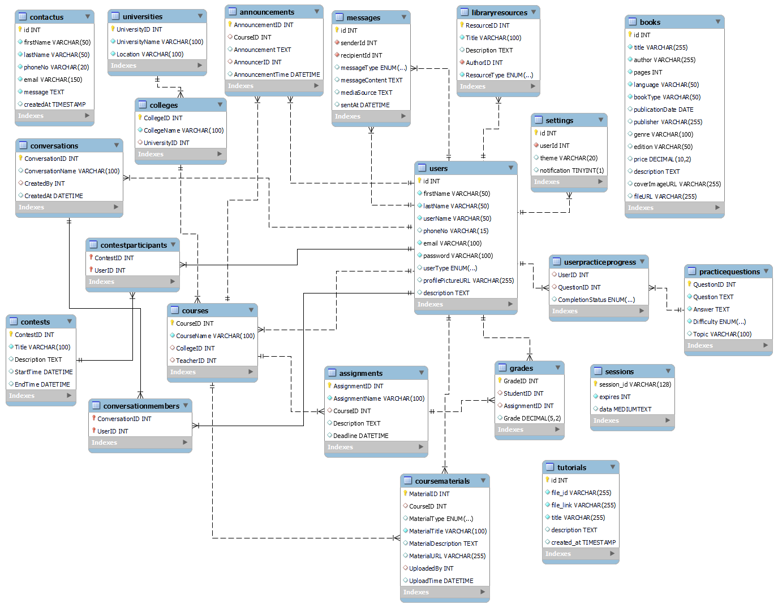

Chapter 16

Flow chart

**Process Overview**

In order to better understand the sequence and interaction of various components in our system, we have developed a comprehensive flow chart. This visual representation delineates the step-by-step process flow, highlighting critical decision points, dependencies, and the overall workflow. The flow chart serves as a blueprint for both existing procedures and future improvements, providing a clear and concise depiction of how tasks progress from initiation to completion.

**Purpose and Scope**

The primary purpose of this flow chart is to offer a detailed visualization of the operational process, making it easier to identify potential bottlenecks, inefficiencies, and areas for optimization. By mapping out each stage, we can ensure all stakeholders have a common understanding of the workflow, facilitating better communication and coordination.

**Key Elements**

The flow chart includes the following key elements:

* Start and End Points: Indicate the beginning and conclusion of the process.
* Process Steps: Represent individual tasks or actions that are carried out.
* Decision Points: Show points where a decision must be made, leading to different branches of the process.
* Inputs and Outputs: Identify the resources required and the results produced at each stage.

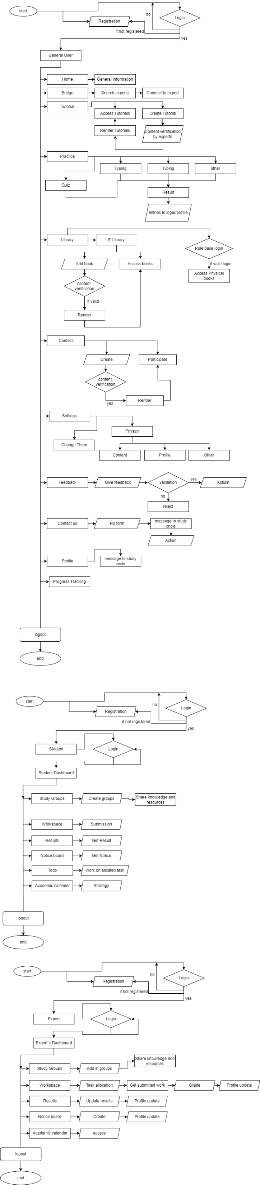

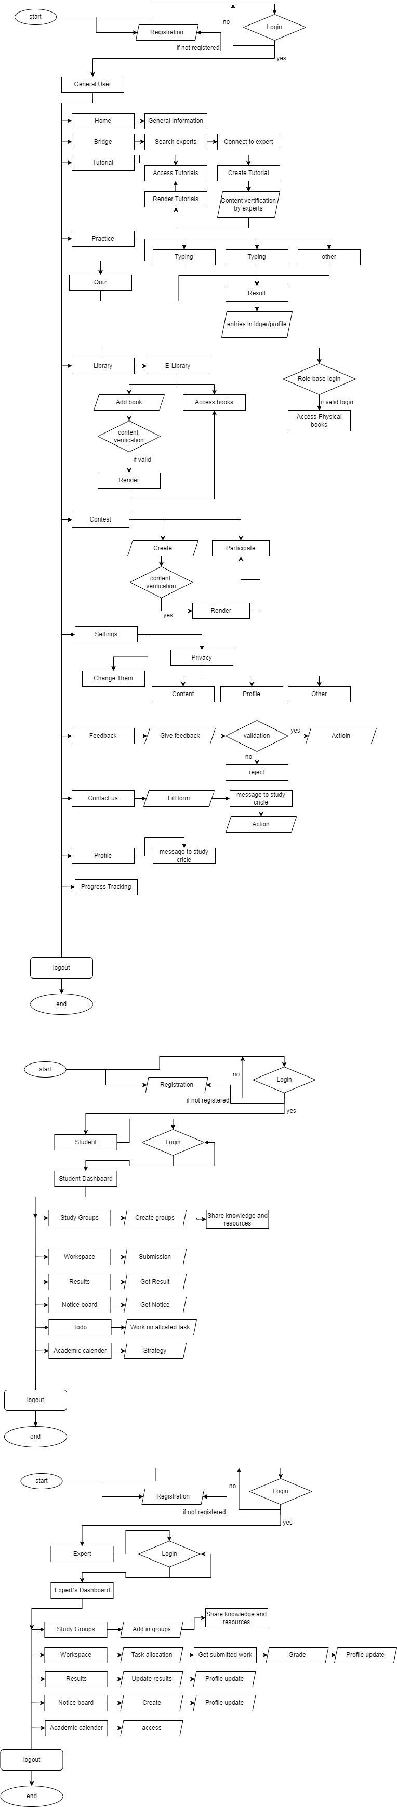

Chapter 17

File and Folder Structure

The "Study Circle" web application is organized in a systematic file and folder structure to maintain a clean and manageable codebase. This structure follows best practices for MERN stack applications, ensuring that both frontend and backend components are well-organized and scalable. Below is an overview of the project's directory structure and the purpose of each folder and file.

**Project Root**

The root directory of the project contains essential configuration files and subdirectories for both frontend and backend components. It includes:

package.json: Contains metadata about the project and lists the dependencies for both frontend and backend.

app.js: The main entry point for the backend server.

This structured organization ensures that the "Study Circle" application is modular, easy to navigate, and scalable for future development and maintenance. Each directory and file serves a specific purpose, contributing to the overall functionality and performance of the application.

**Backend File and folder structure**

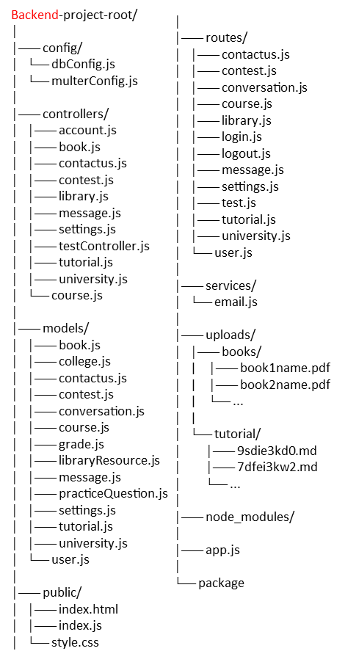

**Frontend File and folder structure**

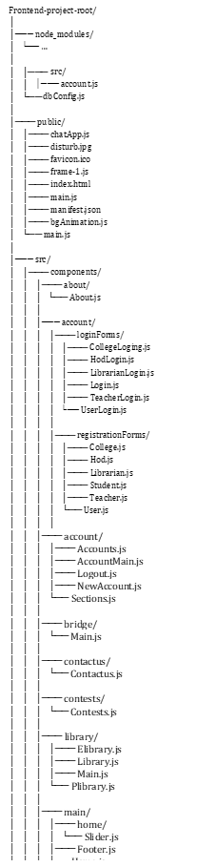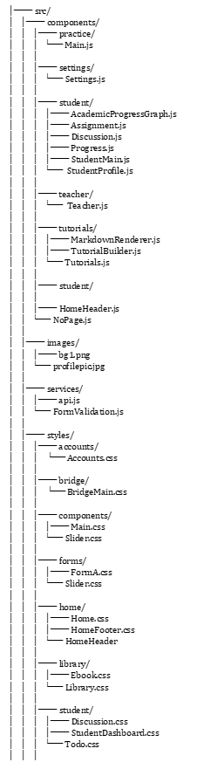

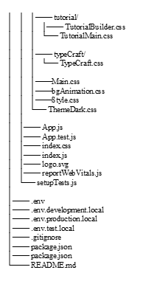

Chapter 18

Conclusion

In conclusion, Study Circle is a comprehensive web platform designed to provide students, departments, and colleges with an efficient and effective way of managing their academic needs. The platform offers a range of features such as the evaluation system, library, practice platform, and contests, which help students learn and prepare for exams effectively. Additionally, it also provides a space for students to interact and share their knowledge with each other.

With Study Circle, teachers can easily track their students' progress and provide feedback to help them improve. The platform also enables teachers to create quizzes and assignments to assess their students' knowledge and understanding of the material covered in class. Department and college administrators can also use Study Circle to manage their academic affairs such as creating schedules, managing enrolment, and tracking students' academic performance.

The platform is accessible from anywhere and at any time, making it convenient for students to access study materials and resources on the go. With a vast library of study materials, students can quickly search for and find the resources they need to improve their academic performance. Moreover, the Practice Platform provides students with a safe environment to practice and improve their skills in various subjects.

The contests offered on Study Circle provide students with a chance to showcase their skills and knowledge while competing against their peers. The platform offers a range of contests across various subjects, providing students with opportunities to learn and grow.

Privacy is a crucial aspect of Study Circle, and the platform ensures the protection of personal information and data. The platform's security protocols are designed to protect students' data and prevent unauthorized access.

Chapter 19

Research

The development of Study Circle as an online platform for students to access study materials and evaluation tools was based on extensive research in the field of education technology. The goal was to create a comprehensive, user-friendly platform that would help students to learn more effectively and efficiently.

The research that informed the development of Study Circle focused on several key areas. First, it looked at the challenges that students face when studying and how technology can be used to address these challenges. This included issues such as time management, motivation, and access to resources.

Second, the research examined different learning styles and how technology can be used to cater to these styles. For example, some students learn best through visual aids, while others prefer a more hands-on approach. Study Circle was designed to accommodate different learning styles by providing a variety of study materials, such as videos, interactive quizzes, and simulations.

Third, the research looked at the effectiveness of different types of evaluation tools, such as quizzes and exams. It was found that frequent, low-stakes evaluation is more effective in promoting learning than infrequent, high-stakes evaluation. Study Circle was developed with this in mind, providing students with regular opportunities to test their knowledge and receive feedback on their progress.

Finally, the research examined the role of social learning in education. It was found that collaboration and peer-to-peer learning can be highly effective in promoting learning, especially in online environments. Study Circle includes features that encourage social learning, such as discussion forums and group projects.

Overall, the research behind Study Circle provides a solid foundation for the development of an effective education technology platform. By understanding the challenges that students face, the different ways that people learn, and the most effective evaluation methods, Study Circle was able to create a platform that is both comprehensive and user-friendly.

Chapter 20

Project Code Details

The program code referenced in this report is available on GitHub, providing transparency, accessibility, and collaboration opportunities for interested parties. Below, we provide an overview of the program code, its functionality, and how to access it.

**Repository Information**

Repository Name: study-circle

Repository URL: <https://github.com/Artist-dk/study-circle.git>

Chapter 21

References

**Everyday Democracy (Study Circles Resource Center)**

Description: Everyday Democracy, formerly known as the Study Circles Resource Center, provides resources and support for community-based discussions and actions. They have facilitated numerous study circles across the United States focused on issues like racial equity, education, and civic engagement.

Website: Everyday Democracy

Publications: Everyday Democracy offers a variety of publications and toolkits for organizing and facilitating study circles, available on their website.

**Workers' Educational Association (ABF), Sweden**

Description: The Workers' Educational Association (ABF) is one of Sweden's largest adult education organizations, organizing thousands of study circles annually. Topics range from cultural studies and arts to political education and social issues.

Website: ABF

Publications: ABF publishes reports and educational materials related to their study circles, which can be accessed through their website or by contacting their offices.

**National Issues Forums (NIF)**

Description: NIF promotes public deliberation and discussion on national issues through study circles and forums. They provide issue guides and other resources to help communities engage in meaningful dialogue.

Website: National Issues Forums

Publications: NIF offers a range of publications, including issue guides and reports on public deliberation outcomes, available on their website.

**The Study Circles Handbook by Sandy Heierbacher**

Description: This handbook provides a comprehensive guide to organizing and facilitating study circles, including practical tips and strategies for effective discussions.

Publication: Heierbacher, S. (2008). The Study Circles Handbook. Topsfield Foundation.

Availability: The handbook can be found online or through educational resource centers and libraries.

**Public Conversations Project (PCP)**

Description: PCP facilitates dialogues on divisive issues through structured discussion groups similar to study circles. Their work focuses on improving understanding and relationships among participants.

Website: Public Conversations Project

Publications: PCP provides guides and case studies on dialogue facilitation, which are available for download on their website.

**Kettering Foundation**

Description: The Kettering Foundation conducts research on public deliberation and civic engagement, including the use of study circles in fostering democratic participation.

Website: Kettering Foundation

Publications: Kettering Foundation publishes research papers, reports, and books on public deliberation and study circles, accessible through their website.

These references provide a range of resources and examples of study circles in practice, offering valuable insights into their organization, implementation, and impact.